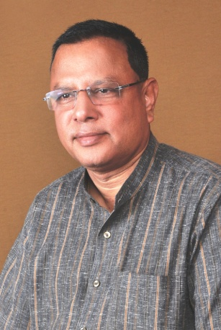**From the desk of the Manager**

Dear Readers,

What is unique and special about St. Paul's School? St. Paul's is not a just a school but a temple of learning and it has been imparting high quality education for the last 32 years. Based on the principles of SFS society's education. The goal of SFS's education is the all round development of the child and form him/her into a well balanced person in an age when success is associated only with academic excellence . the education imparted by St. Paul's School accentuates the holistic transformation of the person is vital for success and happiness in life.

Hence it strives to promote intellectual development, emotional development, spiritual development, moral development and physical development of the child. The curricular, co-curricular and extracurricular activities of the school are designed to achieve this goal and produce well educated, mature and highly creative human resources for the nation. The School makes every effort on a regular basis to adopt and update its curricular and co-curricular activities to make education relevant and learning experience challenging and enjoyable for the students.

The administration of St. Paul's is very caring and compassionate. It takes great care to attract and recruit teachers who will help the school achieve the objectives of the school education. The school strongly believes that every child is precious and a gift from God to the School. Therefore, the School takes pain to make sure every child gets individual attention and personal care. The teachers are St. Paul's take teaching profession as a challenging vocation. They take personal interest in every child and help the child discover and develop all his/her talents and potentials. The School provides all facilities to the children for their all round development by creating an ambiance conductive to self discovery in an atmosphere of safety and security of every child. St. Paul's School believes that real education of a child is collaborative effort of the School and the parents. There is certain knowledge about the child which the parent have but not he teachers. Similarly, there is certain information about the child which the teachers have but not the parents. Hence, a mutual sharing of information about the child can help both do better than the children whose parent do not interact with the teachers. There for, the School welcomes and encourages parent to interact frequently with teachers to help the child blossom into a well - rounded human person.

Education without the right values is dangerous. Hence St. Paul's promotes value based education. It inculcates in every child a profound sense of justice, incorruptible integrity and courage to speak the truth even when everything goes against them. They are motivated to follow the spirit of constant quest for excellence in everything they do. The students are taught how to respect others and be sensitive and companionate towards others especially the needy and suffering. St. Paul's believes it value based education will bring about the desired transformation of the whole person and make them men and women of character and responsible citizens with a socially sensitive conscience. The value based St. Paul's education, self discipline and high academic standard maintain by the school help the students face the challenges of life with courage, confidence and conviction. It enables them to turn challenges into opportunities and opportunities into achievable targets. In short, St. Paul's School experience gives its students wings to fly. For most students, the School becomes a home away from home because of the strong family spirit they experience in the school. Hence, it is said, "Once a Pauling, always a Pauling".

This is what makes St. Paul's School unique and special. I wish St. Paul's School all the very best for the future.

**-Rev. Dr. Valerian Fernandes**